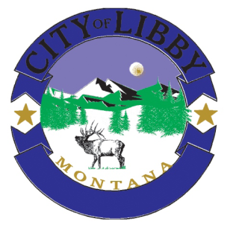City of Libby

952 E. SPRUCE | POST OFFICE BOX 1428

LIBBY, MT. 59923 | Phone 406‐293‐2731| Fax 406‐293‐4090 | Website: [www.cityoflibby.com](http://www.cityoflibby.com)

Cemetery/Parks Committee Agenda

Thursday, 17 March 2022 at 12:00 pm

City Hall, Council Chambers

* Call Meeting to Order

1. Discuss playground equipment at Fireman’s Park.
2. Working meeting.

* Public Comment
* Adjournment

**Posted:**  3/14/22